Objects and its internal representation in Javascript

Object:
In JavaScript, an object is a standalone entity, with properties and type. Compare it with a cup, for example. A cup is an object, with properties. A cup has a colour, a design, weight, a material it is made of, etc. The same way, JavaScript objects can have properties, which define their characteristics.
Creating Objects in JavaScript:
- By object literal
- By creating instance of Object directly (using new keyword)
- By object literal:
The syntax of creating object using object literal is given below:
Property and value is separated by colon(:).
Example:
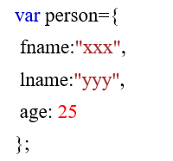

By creating instance of Object directly (using new keyword):
The syntax of creating object directly is given below:
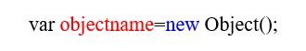

Here, new keyword is used to create object.
Example:
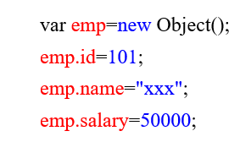

Accessing JavaScript Objects:
The syntax for accessing the property of an object is:
objectName.property
or
objectName[“property”]
Accessing ‘fname’ from example 1 using dot operator,

Accessing ‘name’ form example 2 using [],


